Dana Ewing / Kindergarten Math / 2-11-22
Lesson 11: Number Lines
- TOPIC
  - Students will use number lines to demonstrate number sentences for addition and subtraction.

- STANDARDS/OBJECTIVES
  - CC.2.1.K.A.1 - Know number names and write and recite the count sequence.
  - CC.2.2.K.A.1 - Extend the concepts of putting together and taking apart to add and subtract within 10.
  - Given a number line, TSWBAT physically and verbally demonstrate how to count to the left or right for subtraction and addition for at least 2 out of 3 trials.

- TEACHING PROCEDURES
  - Anticipatory Set
    - Review the left and right sides with kids by playing a quick warm-up game. You say “left” or “right”, and they have to raise that hand. If they raise the wrong hand, they are out.
    - Finish the game by holding out your hands and showing the students the “L trick” to know which hand is the left hand.
  - Development 1
    - Ask the students if they know what the object on the floor is called (a number line) and review the basic parts. Hop across the number line and have the students count the numbers with you.
    - Point out how the students counted by one each time.
    - Start at 3 and add 2. Before hopping, say, “Let’s find 3+2.” Emphasize starting at the first number, 3, and moving to the right to add numbers.
    - Show that adding should give them a bigger number.
    - Move to 6 and say that now you want to subtract. Tell the kids to always start with the biggest number when they see a minus sign. Say the number sentence 6-4, and have the students count out loud as you hop to each spot.
    - Each time you land on the final number, circle it with your finger and say the whole number sentence again.
    - Explain to the students that they will practice using number lines to add and subtract in the next few stations.
  - Guided Practice
    - Split the students into their three usual math groups for stations, with group 1 coming to the big number line last.
    - Station 1:
      - Students will receive a worksheet with number sentences, and they must take turns hopping on the number line or using their hands to solve each equation.
    - Station 2:
      - Students will practice using their number line bookmarks to solve addition and subtraction problems using more/less dice.
    - Station 3:
      - Students will create a dotted number line and practice equations with flashcards (see picture below).
  - Independent Practice
    - Have students take Ziploc bags home with flashcards to help them learn number sentences using the number line.
  - Closure
    - Have the students hop through the number line to put their things away and line up for lunch.

- MATERIALS
  - Tape for number line
  - Labeled post-its for enrichment number line
  - Number sentence worksheet
  - Number line bookmarks
  - More/less dice
  - Flashcards for practice
  - Markers
  - Dotted umber line worksheets

- ADAPTATIONS/MODIFICATIONS
  - For students who struggle to focus for long periods of time, I created a lesson with lots of movement and interactive activities.
  - For Simon and Isaiah’s vision problems, I will use brightly colored tape and big numbers on the number line.
  - Higher-grouped students will receive Ziploc problems ranging from 1-20.
  - With less time, I will use less examples with the flashcards. Students can finish any worksheets for homework.
  - With more time, I will have the students come up with their own number sentences for their friends to solve using their bookmarks or bags.

- EVALUATION
  - Formative – In-class answers, creation of number line, discussion
  - Summative – Number line worksheet

- REFLECTION
  - Were the students motivated to participate? Did they understand the left-to-right concept of a number line? Could they complete the activities with enough time?
  - Did I include good examples? Were my directions clear? What would I do differently?
Number Line Hop
Hop on the number line to find your answers!

- 1 + 5 =
- 7 - 3 =
- 2 + 1 =
- 9 – 6 =
- 4 + 4 =
- 10 – 5 =
- 8 + 2 =
- 4 – 3 =

Number Line Hop
Hop on the number line to find your answers!

- 12 + 3 =
- 16 - 12 =
- 14 + 4 =
- 18 - 9 =
- 4 + 7 =
- 20 - 7 =
- 10 + 5 =
- 19 - 16 =

3 + 6 | 8 + 1
2 + 5 | 6 + 4
1 + 3 | 7 + 2
2 + 1 | 9 + 1
5 - 3 | 8 - 1
7 - 4 | 6 - 0
10 - 2 | 9 - 8
2 - 2 | 4 - 3
10 + 4 | 12 + 7
3 + 15 | 19 + 1
8 + 6 | 7 + 9
13 + 7 | 11 + 8
12 - 5 | 19 - 8
13 - 7 | 15 - 3
19 - 16 | 20 - 11
17 - 10 | 14 - 13

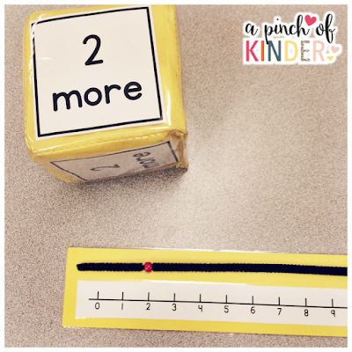
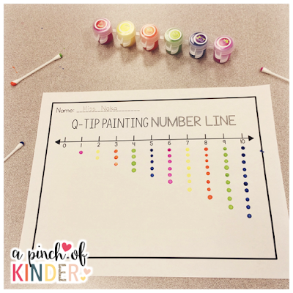
Ideas and Inspiration from:
A Pinch of Kinder (http://www.apinchofkinder.com/2016/02/teaching-number-lines-in-fdk.html#more)
Highland Heritage Homeschool (http://highlandheritage.blogspot.com/2014/01/kindergarten-tidbits-from-december-and.html)

